GST E-Book
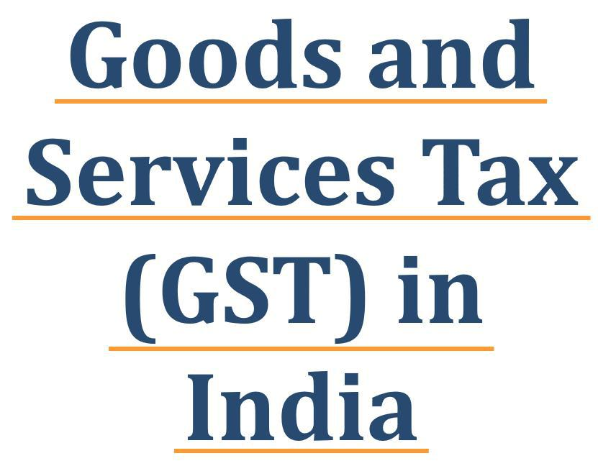

GST E-Book


This E-book will help you understand the basics of GST, important terminologies and concepts, and how this might affect your business in the long run.

This book will also help to Students of Commerce, finance, business professionals, entrepreneurs, tax practitioners and accountants will find this e-book comprehensive and helpful in understanding GST.

GST E-Book

Content

- GST meaning and overview

- GST Structure vs Old Indirect Tax Structure

- Implementation of GST And Acts of GST

- Whom to Register under GST

- Who is Exempted from Register under GST

- GST Composition Scheme

- Invoice and Its Format under GST

- Bill of Supply and Its Format under GST

- E – Way Bill under GST

- Time of Supply under GST

- Place of Supply of Goods under GST

- Place of Supply of Services under GST

GST E-Book

1. GST meaning and overview

Meaning and Overview-:

Goods and Services Tax (GST) is an indirect tax levied in India on the sale of all type of goods and services Except Some Petroleum products and Alcoholic drinks for human these are taxed separately by the individual state governments. This tax came into effect from July 1, 2017, through the implementation of one hundred and first amendment by the Government of India.

- GST is one indirect tax for the whole nation, which will make India one unified common market.

- GST is a vast reform in Indian indirect taxation, the likes of which the country has not seen after Independence.

- GST is a single Tax on both supply of goods as well as supply of services

- GST is a system of taxation will simplify indirect taxation for both (Tax Payer and Tax collector.

- GST will reduce complexities of number of Taxation because in GST will replace many types of indirect taxes (shown as under)

- GST will also remove the cascading effect.

- GST will change the way to do business in India.

- GST is combination of 5 acts (CGST, SGST, IGST, UTGST & CESS Act, 2017)

- GST will have huge impact on Indian economy and all Business (Big, Medium and Small)

- Goods and Services Tax (GST) replaced existing following multiple Indirect taxes levied by the central and state governments

1

www.tutorstips.com/category/tax-laws/goods-and-services-tax

GST E-Book
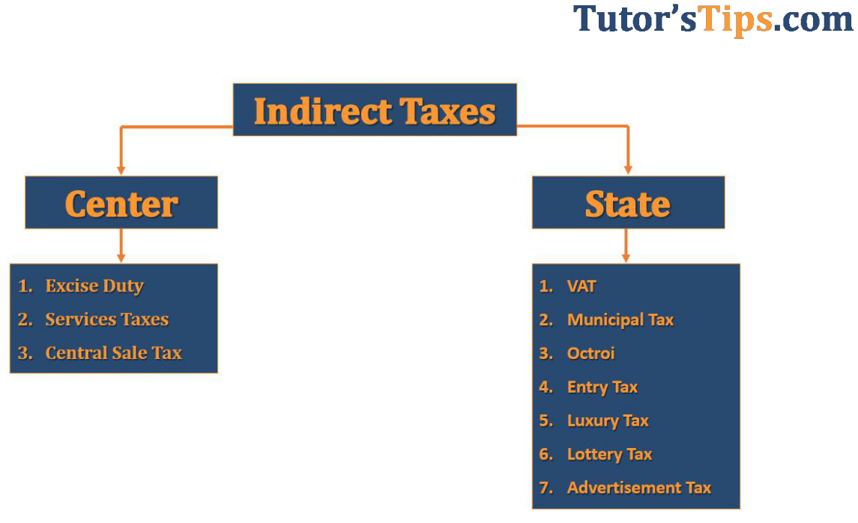

- GST will Collect in Five parts (Shown as in Diagram)
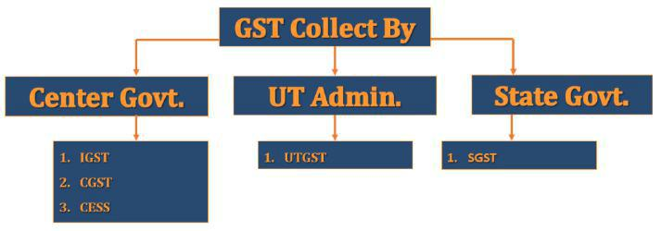

- Manufacturer or Trader will supply their goods with in-state then on that supply CGST and SGST will be charged or collected.

- When he supplies outside from their State (Means to another state like from Punjab to Himachal) then on that supply only IGST will be charged or collected.

- When he supplies outside from their State (Means to another state like from Punjab to Chandigarh/UT) then on that supply CGST and UTGST will be charged or collected.

2

www.tutorstips.com/category/tax-laws/goods-and-services-tax

GST E-Book

2. GST vs Old Indirect Tax Structure

Here is a huge change made by govt. in new Indirect tax (GST) as compare with old Indirect Taxes. In old Indirect Tax, the structure has a major problem of cascading effects (It means a tax on tax).

We will explain cascading effects by following stage-:

- Stage 1-:

On the First stage, a manufacturer of Shoes will purchase raw material from anyone for Rs. 1,000 he has to pay 10% tax on it the total lending cost of raw material will be Rs. 1,100(cost=1,000 + tax=100).

- Stage 2-:

On Second Stage a manufacturer sold their final product to wholesaler @ Rs 1,500/- (Cost to manufacturer = 1100 + manufacturing cost & profit= 400), Now Manufacturer has to pay tax @ 10% on the price of the product it means total cost lending of the product is Rs. 1,650/- (Total price of product 1,500 + Taxes 150).

- Stage 3-:

On third stage a wholesaler sold this product to trader @ Rs 2,000/- (Cost to wholesaler = 1650 + wholesaling cost & profit= 350), Now Wholesaler has to pay tax @ 10% on the price of the product it means total cost lending of the product is Rs. 2,200/- (Total price of product 2,000 + Taxes 200).

- Stage 4-:

On Fourth stage a Trader sold this product to Consumer @ Rs 2,500/- (Cost to trader = 2200 + Trader cost & profit= 300), Now Trader has to pay tax @ 10% on the price of the product it means total cost lending of product to Consumer is Rs. 2,750/- (Total price of product 2,500 + Taxes 250).

GST aims to solve this problem by introducing seam-less Input Tax Credit (ITC). Today, the tax that you pay on material purchases cannot be claimed from output tax. This is set to change with ITC.

3

www.tutorstips.com/category/tax-laws/goods-and-services-tax

GST E-Book

We will Explain GST effects by following stage-:

- Stage 1-:

On the First stage, a manufacturer of Shoes will purchase raw material from anyone for Rs. 1,000 he has to pay 10% tax on it the total lending cost of raw material will be Rs. 1,100(cost=1,000 + tax=100).

- Stage 2-:

On Second Stage a manufacturer sold their final product to wholesaler @ Rs 1,500/- (Cost to manufacturer = 1100 + manufacturing cost & profit= 400), Now Manufacture has to pay tax @ 10% on only addition made in product by him it means he has to pay 10% on Rs 400/- only (Tax = Rs 40/- only).

- Stage 3-:

On third stage a wholesaler sold this product to trader @ Rs 2,000/- (Cost to wholesaler = 1540 + wholesaling cost & profit= 350), Now Wholesaler has to pay tax @ 10% on only on addition made by his in the price of product (wholesaling cost & profit) by him it means he has to pay 10% on Rs 350/- only (Tax = Rs 35/- only).

- Stage 4-:

On Fourth stage a Trader sold this product to Consumer @ Rs 2,500/- (Cost

to trader = 2200 + Trader cost & profit= 300), Now Trader has to pay tax @ 10% on only on addition made by him in the price of product (Trading cost & profit) by him it means he has to pay 10% on Rs 300/- only (Tax = Rs 30/-only).

4

www.tutorstips.com/category/tax-laws/goods-and-services-tax

GST E-Book

We will explain cascading effects with help of following tables-:
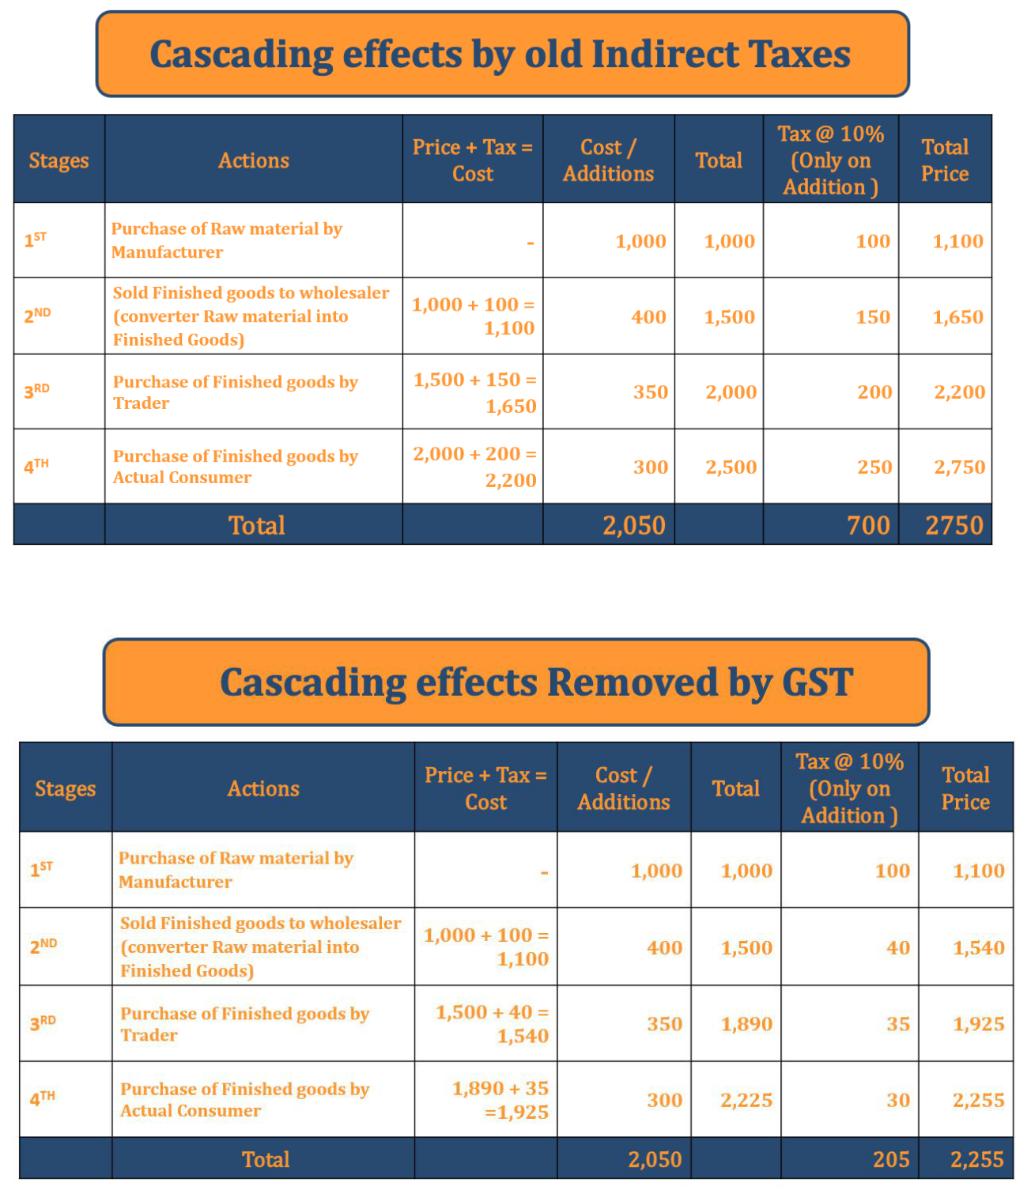

In the end, the price of product reduced because of a lower tax liability (Removing of cascading effect by GST). The final value of the Shoes also therefore reduced from INR 2750 to INR 2255, thus reducing the tax burden on the final customer.

So here is the implementation of GST consumer will get the same product at a cheap price because it removing cascading effects on the price of products.

5

www.tutorstips.com/category/tax-laws/goods-and-services-tax

GST E-Book

3. Implementation of GST And Acts of GST

Implementation of GST was very difficult because it will subsume multiple indirect taxes and will have to apply whole new Indirect Tax structure nationwide. It levied at every stage of where someone makes an addition to the value of goods. This Taxation system has multi-stage and will collect where it final consumption made.

- Multiple stages: - GST is multi-stage taxation system because it applies to all the level of goods life cycle.
From Manufacturer to End-users

- Final consumption tax: - Because of single tax applicable form manufactured to end user the tax will collect from where actual goods were consumed.

The idea of GST was first mooted in India by Kelkar committee in the year 2004 but idea not implemented because of some political difference.

But after more than a decade, GST implemented Successfully by govt on 01/July/2017.

- For this relevant Bills passed by Lok Sabha and Rajya Sabha

Following bills have passed by Lok Sabha on 29/03/2017 and By Rajya Sabha on 5/4/17

  - The Central Goods and Services Tax (CGST) Bill, 2017

  - The Integrated Goods and Services Tax (IGST) Bill, 2017

  - The Union territory Goods and Services Tax (UTGST) Bill, 2017

  - The Goods and Services Tax (Compensation to States) Bill, 2017

  - The State Goods and Services Tax (SGST) Bill, 2017(Each State will introduce its own)

- For the Relevant Following Act was made under GST

  - CGST Act, 2017

  - IGST Act, 2017

  - UTGST Act, 2017

  - SGST Act, 2017

  - CESS Act, 2017

6

www.tutorstips.com/category/tax-laws/goods-and-services-tax

GST E-Book
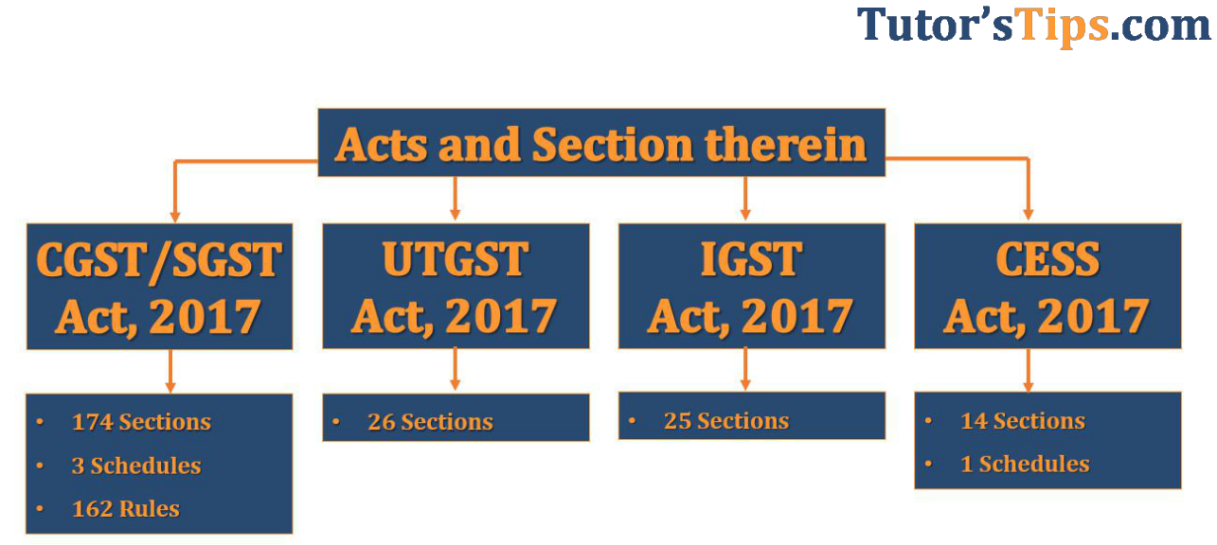

Explanation: -

- CGST – Central Goods and Services Tax

- SGST – State Goods and Services Tax

- IGST – Integrated Goods and Services Tax

- UTGST – Union Territory Goods and Services Tax

We will explain all these terms with a single example as following: -
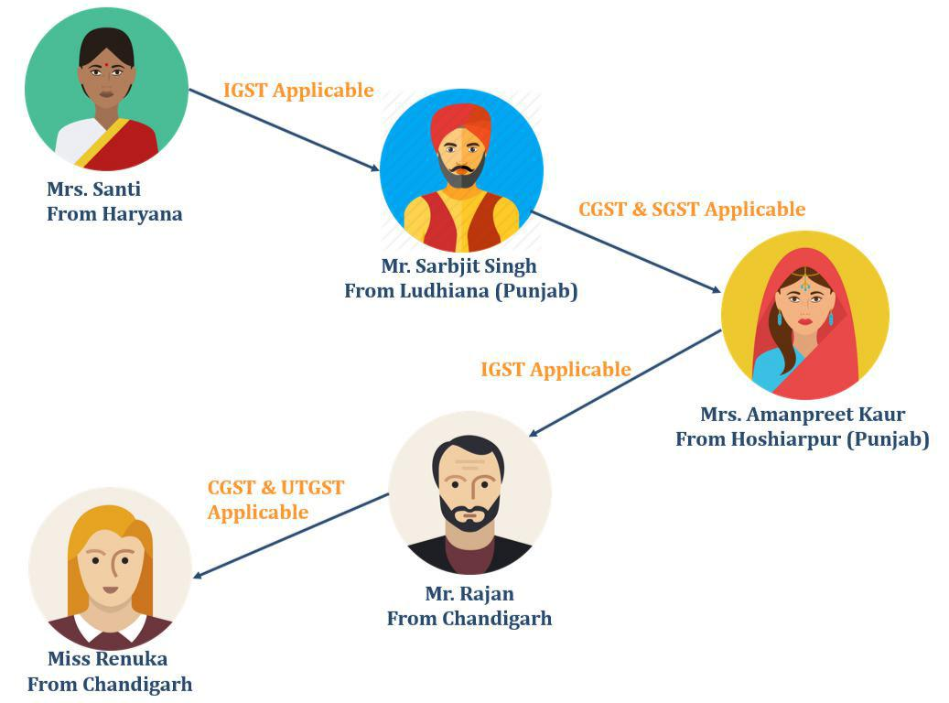

7

www.tutorstips.com/category/tax-laws/goods-and-services-tax

GST E-Book

According to Image: -

- Mrs Shanti from Haryana sold goods to Mr Sarbjit Singh from Ludhiana (Punjab) this type of sale called inter-state sale (Sale outside the State) and on that type of sale IGST will be charge (Rates applicable as per Goods)

- On next stage, Mr Sarbjit Singh from Ludhiana (Punjab) sold goods to Mrs Amanpreet Kaur from Hoshiarpur (Punjab) this type of sale called intra-state sale (Sale within the State) and on that type of sale CGST and SGST both will be charged (Rates applicable as per Goods)

- On next stage Mrs Amanpreet Kaur from Hoshiarpur (Punjab) sold goods to Mr Rajan from Chandigarh(UT), this type of also sale called inter-state sale (Sale outside the State) and on that type of sale IGST will be a charge (Rates applicable as per Goods).

- On next stage, Mr Rajan from Chandigarh(UT) sold goods to Mrs Renuka from Chandigarh, this type of sale called intra-state sale (Sale within the UT) and on that type of sale CGST and UTGST both will be charged (Rates applicable as per Goods)

Rates of GST: - Rate of GST will apply on the type of goods here goods are divided into six Schedule as shown in the image.
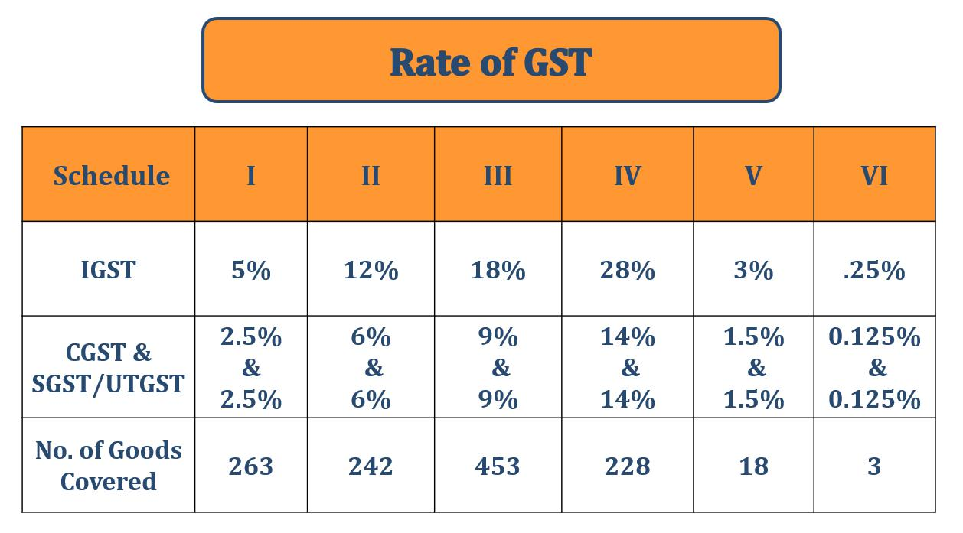

To check your goods rate and HSN code please visit my following website link www.gst.hsn.tutorstips.com


8

www.tutorstips.com/category/tax-laws/goods-and-services-tax

GST E-Book

When is Good and Services Tax (GST) Levied?

Under GST, Taxes will be collected when a taxable event occurs such as the sale of goods or services and advance paid for the supply of goods or services.

Under Old, Indirect Taxation system tax was collected separately on

manufacturing of goods, sale of goods and sale of services by separate

departments

Like:

- On Manufacturing, Excise Duty Applicable

- On Sale of Goods, VAT Applicable

- On Sale of Services, Services Tax Applicable

Now under GST same tax will be collected on a different level of production only rates of tax will vary. As shown in diagram these will divide into 6 parts.

The best example of Different between levied of GST or Old Indirect tax is a bill of the restaurant because in restaurant bill both items include the sale of goods as well as the sale of services.
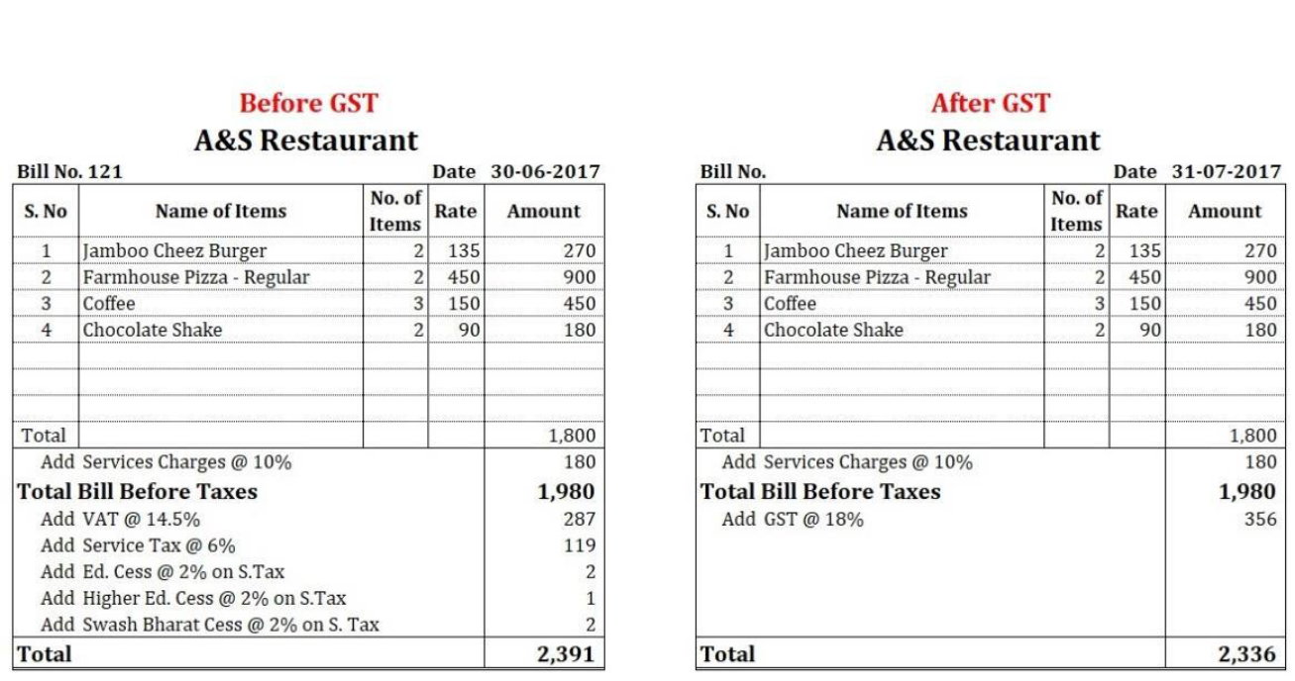

Following are the example of this: -

As image shown that a number of taxes are subsumed into single tax is called GST.

9

www.tutorstips.com/category/tax-laws/goods-and-services-tax

GST E-Book

4. Whom to Register under GST

Now you know the basic terms of GST i.e. what is GST when it will apply is and how much will apply. So now you have to learn when your Business needs to have registered under GST Act: - if following any condition applicable to your business than you have to register under GST Act.

- If your aggregate turnover in a financial year exceeds Rs 20Lacs [Rs. 10 Lacs in case of special category States except J & K] show list as under

- If your turnover does not include the supply of only those goods/services which are exempt under GST Act.

- If you want to supply your goods by E-Commerce (like Amazon, Flipkart, Snapdeal etc.)
- If your business was registered under the Pre-GST law (i.e., Excise, VAT, Service Tax etc.) need to register under GST.
- If you drive the inter-state supply of goods.
- If you are a Non-Resident taxable person.
- If you are Casual Taxable Person.

- If you are Agents of a supplier.
- If you are Taxpayers paying tax under reverse charge mechanism.

Note: -Latest Update:

As per 23rd GST Council Meet on 10th November 2017

E-commerce sellers/aggregators need not register if total sales are less than Rs. 20 lakhs. Notification No. 65/2017 – Central Tax dated 15.11.2017

As per 22nd GST Council meeting of 6th October 2017

Service providers providing inter-state services are exempted from registration if their annual turnover is below 20lakhs (10 lakhs for Special states. 20 lakhs for J&K)

Notification No. 7/2017 – Integrated Tax dated 14th September 2017

Job workers making inter-state supply of services to a registered person are exempted from registration if their turnover is below 20lakhs (10 lakhs for Special states)

Please click on below link to know more about aggregate supplies http://www.cbec.gov.in/resources//htdocs-cbec/gst/aggregate-turnover-in-GST_04aug2017.pdf

10

www.tutorstips.com/category/tax-laws/goods-and-services-tax

GST E-Book

- What is Aggregate Turnover?

The term ‘aggregate turnover’ has been defined in GST law as under:

“Aggregate turnover” means the aggregate value of all taxable supplies (excluding the value of inward supplies on which tax is payable by a person on reverse charge basis), exempt supplies, exports of goods or services or both and inter-State supplies of persons having the same Permanent Account Number, to be computed on all India basis but excludes central tax, State tax, Union territory tax, integrated tax and cess.
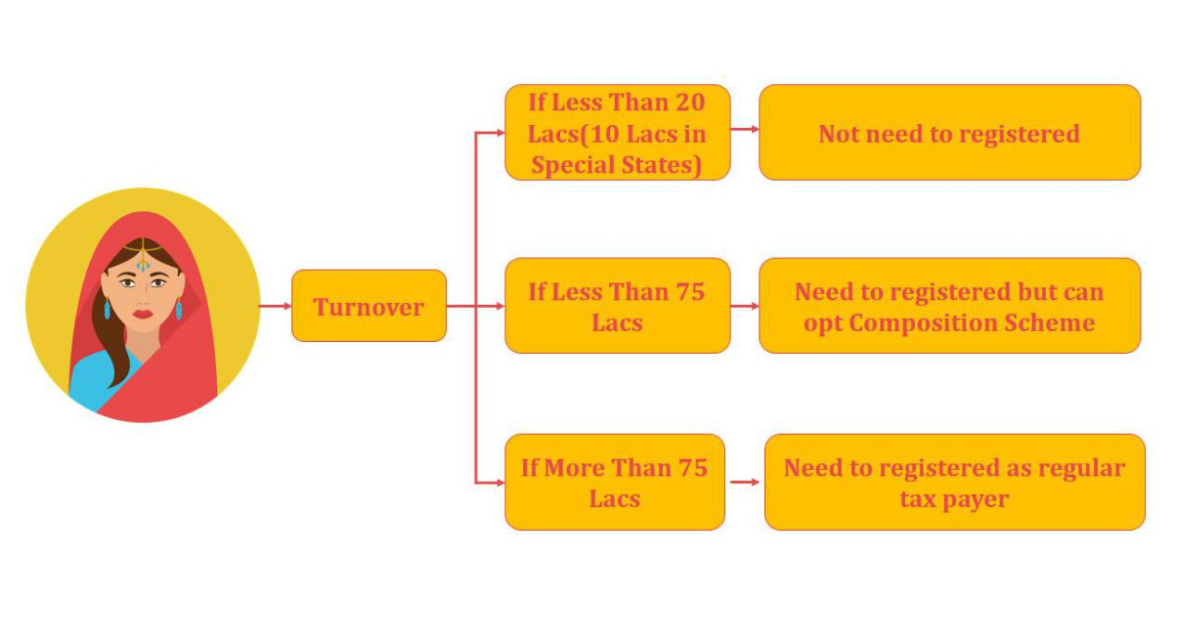

Special Category States under GST

Following states are assigned special status under Goods and Services Tax Law:

- Arunachal Pradesh

- Assam

- Jammu & Kashmir IV. Manipur

- Meghalaya
VI. Mizoram

- Himachal Pradesh XI. Uttarakhand

11

www.tutorstips.com/category/tax-laws/goods-and-services-tax

GST E-Book

- What is Exempted Goods and Services?

Article Compiles list of 149 Type of Goods which are exempt from Tax under GST with respective HSN Code and Description of Goods as per Notification No. 2/2017-Central Tax (Rate) New Delhi, the 28th June 2017

List of Exempted Services under GST-Click to Download

- What is E-Commerce?

E-commerce is buying and selling goods and services over the Internet. E-business is a structure that includes not only those transactions that centre on buying and selling goods and services to generate revenue, but also those transactions that support revenue generation. These activities include generating demand for goods and services, offering sales support and customer service, or facilitating communications between business partners.

IV. What is Pre-GST Law?

Before GST in India, there was a lot of tax law which is now subsumed into GST. So, if your business is already registered under any old indirect Taxation Like Excise, VAT, Services Tax and etc. before 01/07/2017

- What is an inter-state supply of goods?

When on business sold their goods to another state this is called inter-state supply of goods.

VI. Who is a Non-Resident taxable person?

The person who makes the supply of goods or services as a principal, agent and any other capacity in a taxable state or union territory, where GST applies but he doesn’t have a fixed place of Business in India or residence in India. As per GST, you will be treated as a Non-Resident taxable person.

VII. Who is Casual Taxable Person?

The person who makes the supply of goods or services on an occasional basis as a principal, agent and any other capacity in a taxable state or union territory, where GST applies but he doesn’t have a fixed place of Business. As per GST, you will be treated as a casual taxable person.

12

www.tutorstips.com/category/tax-laws/goods-and-services-tax

GST E-Book

Remember following: -

- This type of registration valid only for 90 days

- It can be extended to 90 days again after expiry of first 90 days.

- In this type of registration, taxpayer has to deposit Tax liability in advance and it will be used as ITC

- if extension made than addition tax liability must be deposited as required in advance again.

VIII. Who are Agents of a supplier?

The GST Act defines an Agent as a person including a factor, broker, commission agent, del-credere agent, an auctioneer or any other mercantile agent, by whatever name called, who

Carries on the business of supply or receipt of goods or services or both on behalf of another

IX. If you are Taxpayers paying tax under reverse charge mechanism.

Reverse Charge means the liability to pay the tax by the person receiving goods and/or services instead of the person supplying the goods and/ or services in respect of specified categories of supplies.

Note:-

- If you have business more than 1 state you have to get separate GSTIN for each state.

- PAN is

13

www.tutorstips.com/category/tax-laws/goods-and-services-tax

GST E-Book

5. Who is Exempted from Register under GST

In this topic, we will get to know about that which type of businesses is not need to get registered under GST. In GST registration is based on what is the nature of their supply of goods and services.

The taxpayers who are exempted from GST Registration are:

- Agriculturists

- Persons falling into Exemption Limit

- Persons making supplies of goods and services which are Nil-

Rated/ Exempt under GST Act.

- Persons making supplies of goods and services which are not covered under GST Act.

- That Supply of Goods or Services which are not covered by GST

- Supplies covered under reverse charge

Now we will explain these in the term with diagrams as follows: -

- Agriculturists: -

A person who cultivate their land to make supplies of products/goods.

Under GST these types of persons are exempted from registration.


14

www.tutorstips.com/category/tax-laws/goods-and-services-tax

GST E-Book

- Persons falling into Exemption Limit: -

GST has some limit of exemption from registration for very small businesses like the local General store in a village and etc. Under GST expect some special states Govt. set a limit of aggregate turnover up to 20 Lacs and for special states limit reduced to 10 Lacs. Like shown as under: -
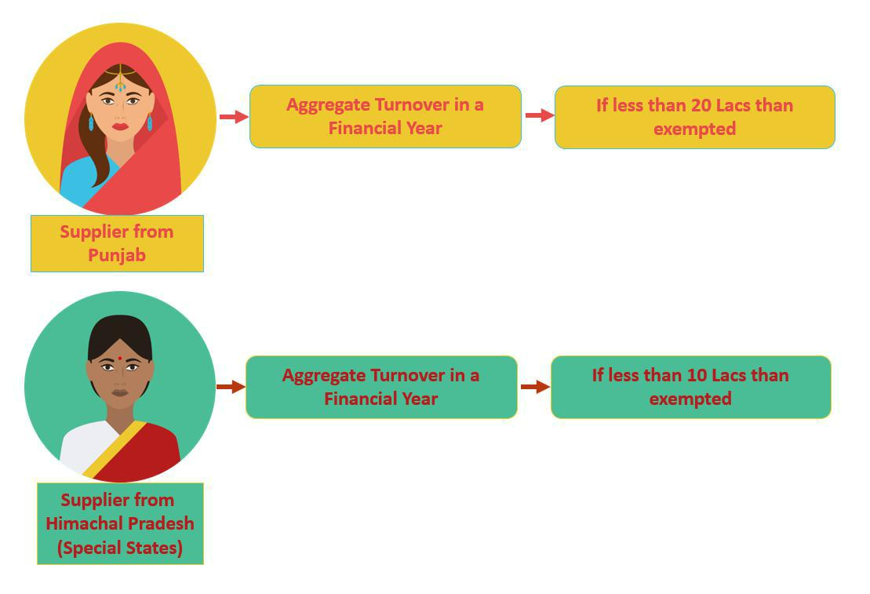

- Persons making supplies of goods and services which are Nil-Rated/ Exempt under GST Act: -

Under GST some Goods/Services of daily needs are exempted. some of these

areas following

- Health Care

- Education

- Services by a veterinary clinic in relation to health care of animals or

birds

IV. a live animal such as Mammals, Birds, Insects

- Meat of bovine animals, fresh and chilled

VI. Onions, shallots, garlic, leeks and other alliaceous vegetables, fresh or

chilled.

VII. Unprocessed foods:- Milk, Egg etc.

15

www.tutorstips.com/category/tax-laws/goods-and-services-tax

GST E-Book


So, if you are dealing with this type of goods than you do not need to register under GST.

- List of Exempted Goods under GST- Click to Download

- List of Exempted Services under GST- Click to Download

- Persons making supplies of goods and services which are not covered under GST Act: -

Under GST some Goods/Services are not covered. It means on these types of goods still old indirect structure is implemented. Some of these areas following

- Petroleum Products

- Electricity

- Alcohol for human consumption IV. Tabaco etc.

So, if you are dealing with this type of goods than you do not need to register under GST.

- That Supply of Goods or Services which are not covered under GST: -

There are some of the services that are not covered under the GST because of these are cover under some other law or exempted. Some of these areas following

16

www.tutorstips.com/category/tax-laws/goods-and-services-tax

GST E-Book

  - Services by an employee

  - Duties of Public elected persons -PM, CM, MP or MLA.

  - Person who is member or director of a body

  - Services provider at funeral

  - Services Provide by any Court

  - Sale of land and building

  - Actionable claims

- Supplies covered under reverse charge: -

There is provision under the act that if any person supplies taxable goods/services on which tax will be paid by the recipient then he does not need to get registered himself under GST.

17

www.tutorstips.com/category/tax-laws/goods-and-services-tax

GST E-Book

- GST Composition Scheme

GST Composition scheme is very convenient scheme made for small-scale industries or businesses. In this scheme, the taxpayer has a fixed rate of tax on their aggregate turnover. Any taxpayer can opt this scheme if their aggregate turnover is less than 1.5 Crore or 75 lacs (latest update as per 23RD GST Council meeting held on 10th Nov 2017) in North-Easter states and Himachal Pradesh.

Key feature: -

- Fixed Rate of Tax on Aggregate Turnover

- ITC (Input Tax credit) not eligible

- Only eligible for intra-state supplies

- Only can issue bill of supply not tax invoice

- Eligibility made on basis of Aggregate supplies

- Monthly Returns are not required file only Quarterly Returns

- Not need to maintain records.

- Single time Tax payment and easy to calculate.

- Reduce workload on small business who trying to grow.

You can understand much better in the example given below: -
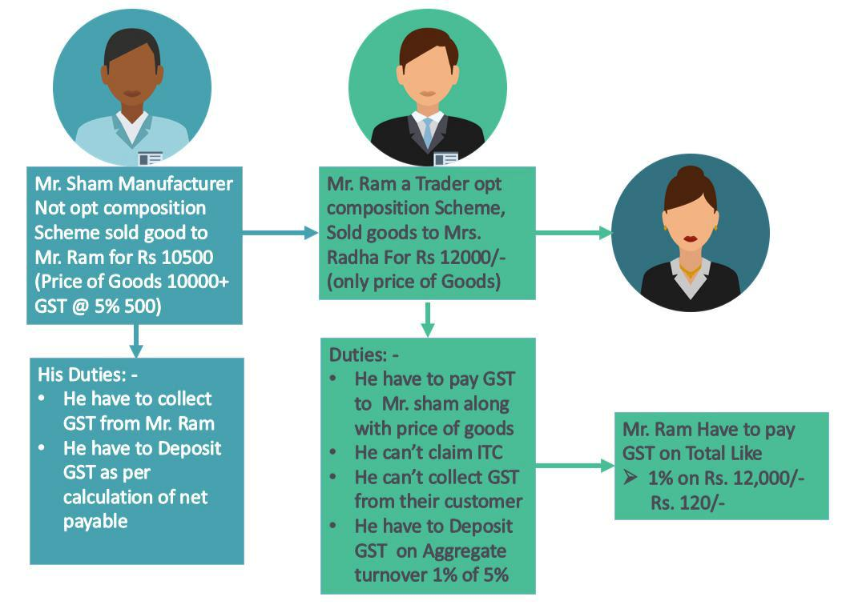

18

www.tutorstips.com/category/tax-laws/goods-and-services-tax

GST E-Book

GST Percentage to be payable as per your type of business shown under:

-
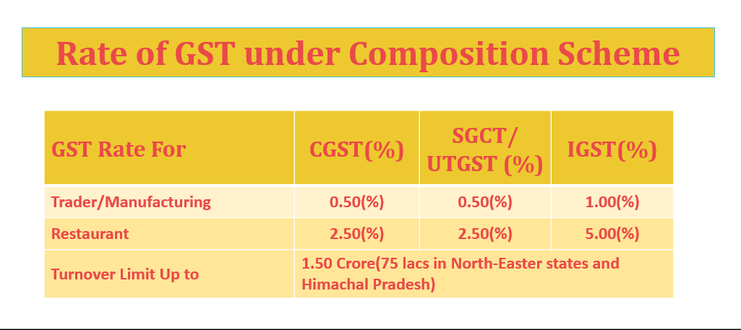

Who can opt this scheme?

Anyone who can fulfil the following conditions: -

- Whose aggregate turnover is less than 1.5 Crore or 75 lacs in North-Easter states and Himachal Pradesh?

- Who is not supplying your goods through E-Commerce marketplace? IV.Who is dealing with exempted supplies of goods under GST?

V.Who is not a Casual taxable person? VI.Who is not a Non-Resident taxable person?

VII.Who is not dealing with tobacco, pan masala and ice cream? VIII.All Services provider expect restaurant related services.

Following are some condition which has to fulfil availing composition scheme under GST

- All the above requirements are conditions but some more as following

- All business registered with the same PAN are treated as composition supply and total aggregate turnover will be fall in threshold limit.

- The taxpayer has to mention “Composite taxable person” on their every bill of supply, notice and signboard place at their business premises.

19

www.tutorstips.com/category/tax-laws/goods-and-services-tax

GST E-Book

- Invoice and its Format under GST

Definition of invoice by Oxford: -

“A list of goods sent or services provided, with a statement of the sum due for these; a bill.”

Introduction: -
A forming invoice is so crucial because this document explains the whole transaction between seller and buyer of goods/services and this is the proof of supplies of goods by the supplier (who sell goods) to the buyer.

Under GST here a two-type invoice: -
1. GST Invoice
  - Bill of Supply

- GST Invoice: -

So, when you are forming your GST invoice you have to enter the following Details into it: -

I. Bill to

- Buyer Name
- Buyer Address (Both Billing as well as shipping)
- Buyer GSTIN (Goods and Services Tax Identification Number)
II.Ship to
You also have to mention shipping address on the invoice in the same format as in billing address.

III.Supplier Details

- Supplies Name
- Supplies Address and Contact
- Supplies GSTIN

IV.Invoice Number: - It will be a unique number for every different invoice and also in increasing order.

V.Invoice Date: - In case supply of goods date will be that date when the actual supply of goods is made.

VI.Items Description: -

- Name of Items
- HSN Code
- Quantity
- MOU (Measurement of Units)
- Rate per Units

20

www.tutorstips.com/category/tax-laws/goods-and-services-tax

GST E-Book

f) Total Taxable amount

VII.Shipping Charges (If any)

VIII.GST(Tax) Details: -

- Type of Tax

  - IGST

  - CGST

  - SGCT/UTGST
- Rate (%) of Tax
- Amount of Tax

IX.Must Mention the Name of Copy on GST Invoice: - GST invoice has a three type of copies as following

- Original Invoice: - It is for buyer
- Duplicate Invoice: - It is for transporter
- Triplicate Invoice: - It is for supplier himself

X. Terms and Condition of supply of Goods (If Any): - XI.Signature or Digital Signature

The format of the invoice can be different as per your convenience but we have provided you one simple format in the following the example, you will understand much better format of GST (TAX) Invoice with it: -

21

www.tutorstips.com/category/tax-laws/goods-and-services-tax

GST E-Book
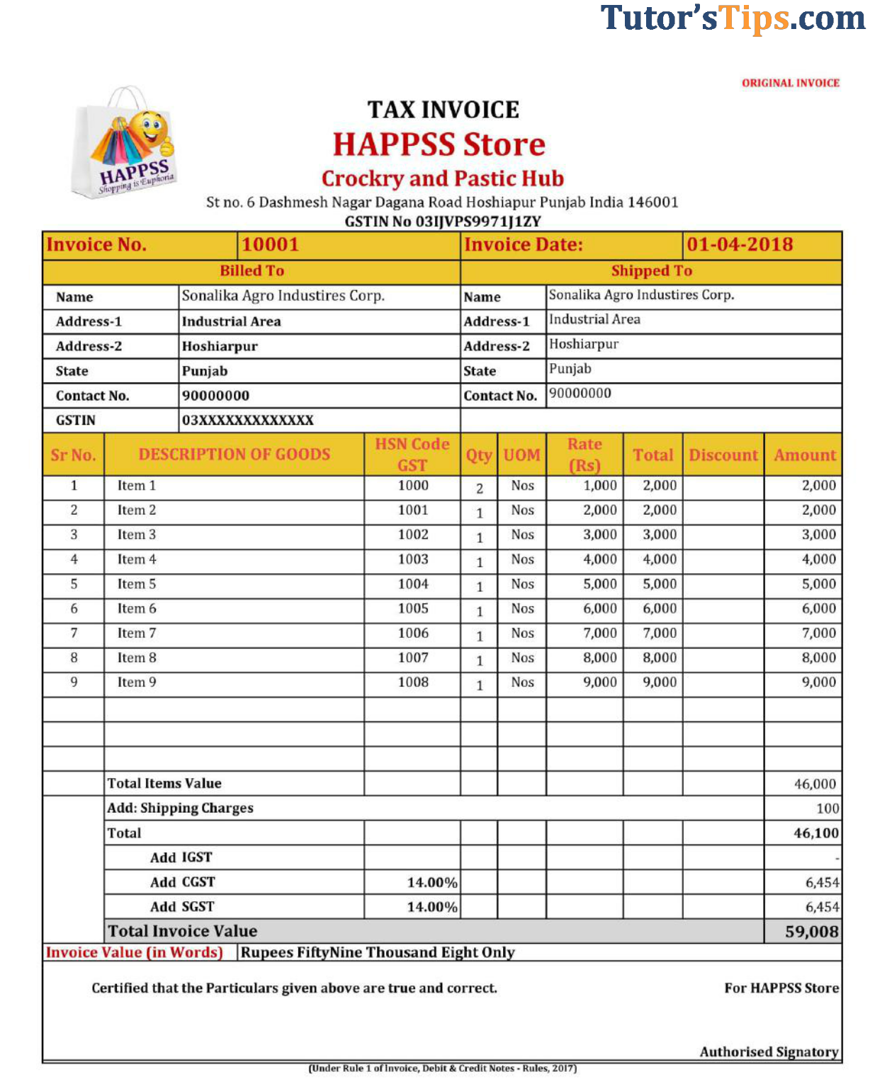

22

www.tutorstips.com/category/tax-laws/goods-and-services-tax

GST E-Book

8. Bill of Supply and Its Format under GST: -

Under GST some following business (registered under GST or not) cannot charge Tax on their goods form their customers in these type of cases Bill of Supply is generated by a businessman and in these cases if you are registered under the GST act except 1 from following cases you cannot issue GST Invoice: -

- If you are Composition dealer under composition scheme.
- If you are Exporter.
- If you are Supplier of Nil-Rated/Exempted Goods.
- If you are Supplier of Non-taxable goods under GST and Non-GST goods and services.

Particulars of Bill of Supply

- Supplier Name, address and GSTIN (If register)
- Buyer Name, Billing address and Shipping address.
- Bill of Supply consecutive number Date of Issue
- Items Description: -
  - Name of Items
  - HSN Code (Required as per Turnover)
  - Quantity
  - MOU (Measurement of Units)
  - Rate per Units
  - Discount (If any)
- Terms and Condition of supply of Goods (If Any)
- Signature or Digital Signature

23

www.tutorstips.com/category/tax-laws/goods-and-services-tax

GST E-Book
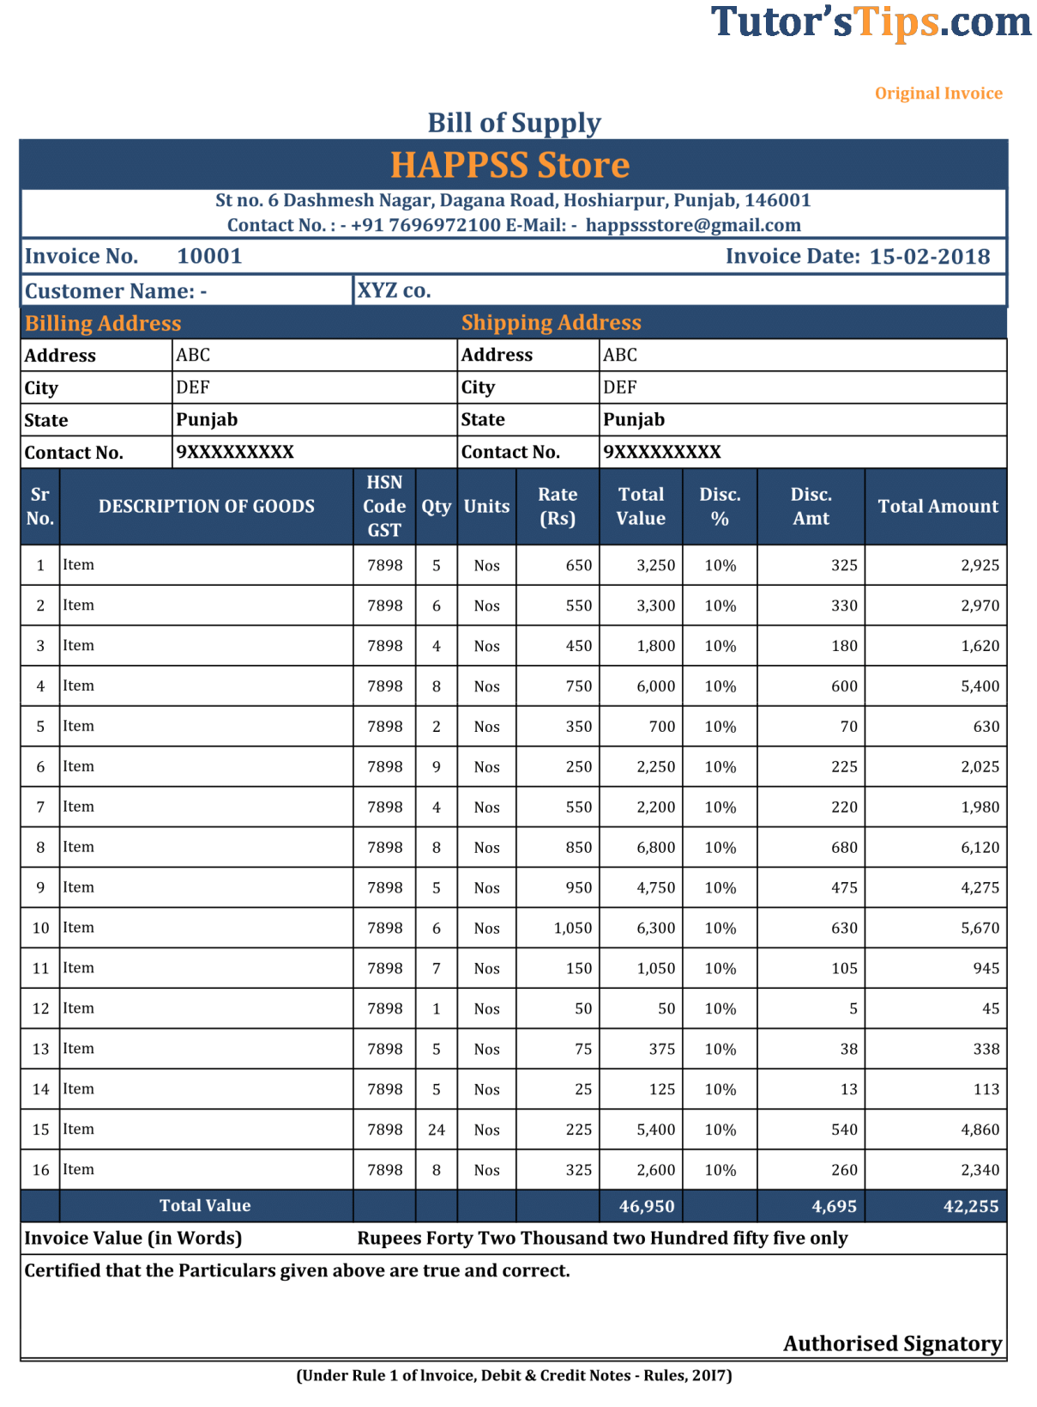

24

www.tutorstips.com/category/tax-laws/goods-and-services-tax

GST E-Book

Section Wise Explanation of BOS (Bill of Supply): - We can divide BOS into 4 sections as following


BOS

1. Header | 2. Customer | 3. Goods | 4. Footer
1. Header | Details | Details | 4. Footer

- Header: - It includes all information about Supplier i. e. Name, Address, GSTIN, contact number, BOS number and Date of BOS.

- Customer Details: -
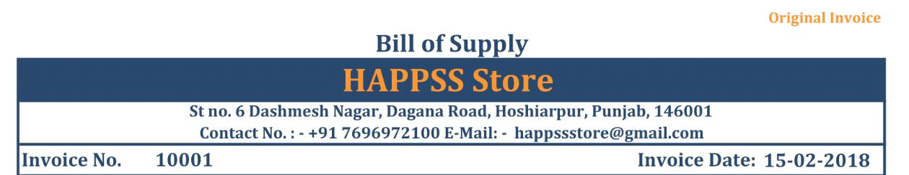

It includes all information about Customer i.e. Name, Address (Billing as well as Shipping, and contact number.
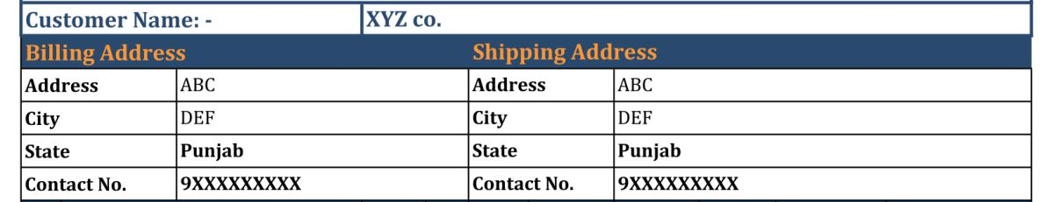

25

www.tutorstips.com/category/tax-laws/goods-and-services-tax

GST E-Book

- Goods Details: - It includes all information about goods i.e. Name, HSN Code, Rate, Units, Discount and etc.
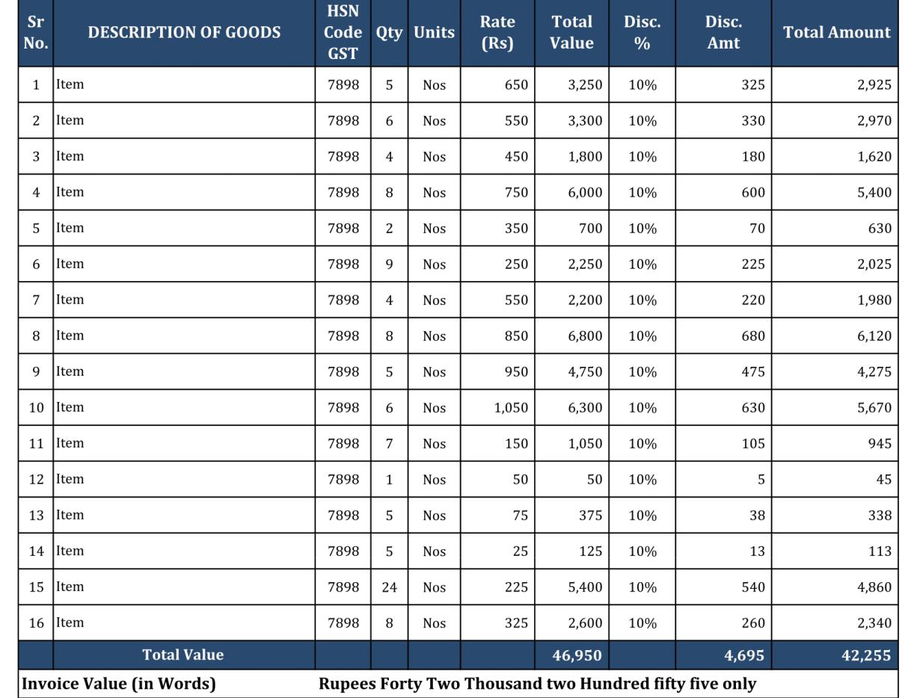

- Footer: - It includes all Terms and conditions, the signature of accountant/ authorized Signatory and etc.
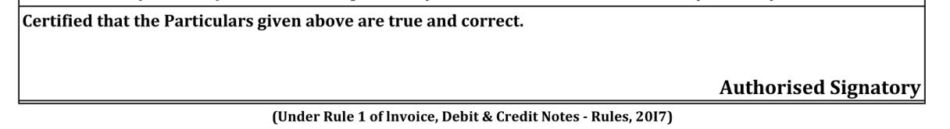

26

www.tutorstips.com/category/tax-laws/goods-and-services-tax

GST E-Book

9. E – Way Bill And its format under GST

E-way Bill is an electronically generated document which is required for transportation of goods from one place to another (whether it is inter-state of intra-state) if the value of goods more than Rs. 50,000/-.

Important Point: -

- It is a mandatory document from 01/02/2018 for movement of goods from one place to another.

- If transporter carrying multiple consignments then he needs to generate a consolidate E-way Bill for all.

- If any case transporter needs to transfer goods from one vehicle to another then he has to generate a new E-way bill for a new vehicle.

- E-Way Bill can be generated and cancelled from GST Portal, app and by SMS.

- When an e-way bill is generated a unique e-way bill number (EBN) is allocated and is available to the supplier, recipient, and the transporter

- For certain specified Goods, the e-way bill needs to be generated mandatorily even if the Value of the consignment of Goods is less than Rs. 50,000:

  - Inter-State movement of Goods by the Principal to the Job-worker

    - Inter-State Transport of Handicraft goods by a dealer exempted from GST registration

When E- Way Bill Needed to generate?

When value of goods more than 50,000/-(either single invoice value is 50,000/- or consolidate of all invoices value which is carried by one vehicle/conveyance)

- If goods are transferred in relation to a supply (i.e. sale of goods)

- If goods are transferred for a reason other than supply (i.e. Sale Return/Branch transfer)

- If goods are supplied by the unregistered dealer to registered dealer.

What is supply under E-way Bill?

- It means sale - Means transferred goods for some consideration (Payment)

- It means Transfer – if goods transferred from head office to branch

- It means Exchange/Barter – if goods transferred against consideration of other goods from the recipient.

27

www.tutorstips.com/category/tax-laws/goods-and-services-tax

GST E-Book

Who needs to generate an E-Way Bill?
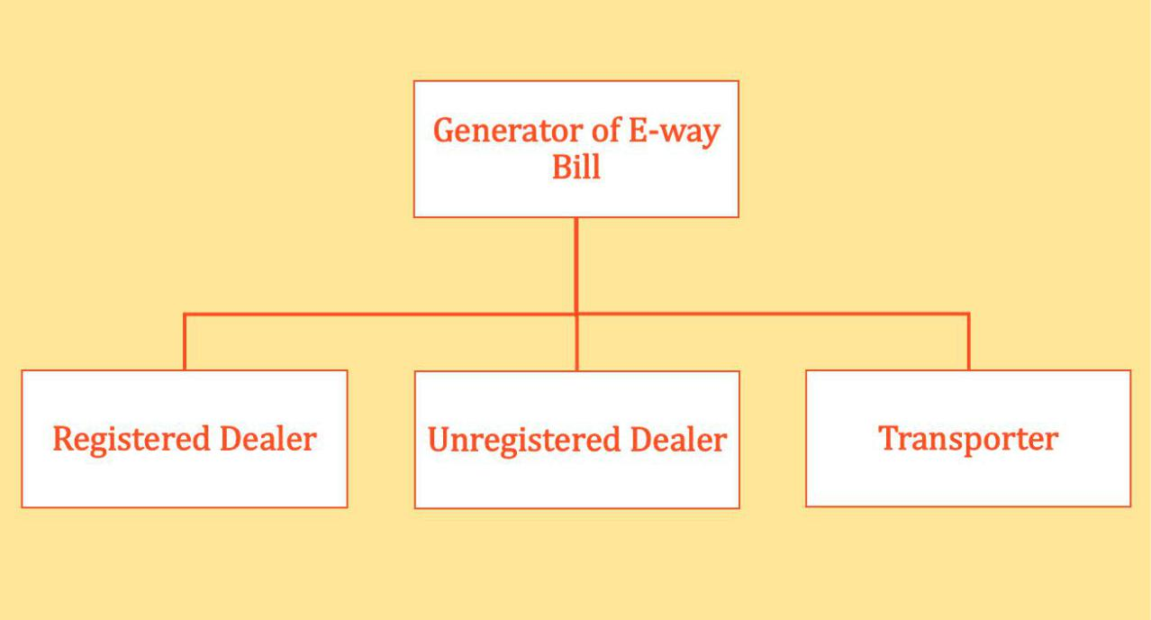

- Registered Person – E-way bill must be generated when there is a movement of goods of more than Rs 50,000 in value to or from a Registered Person. A Registered person or the transporter may choose to generate and carry e-way bill even if the value of goods is less than Rs 50,000.

- Unregistered Persons – Unregistered persons are also required to generate e-Way Bill. However, where a supply is made by an unregistered person to a registered person, the receiver will have to ensure all the compliances are met as if they were the supplier.

- Transporter – Transporters carrying goods by road, air, rail, etc. also need to generate e-Way Bill if the supplier has not generated an e-Way Bill.

Note: -

  - Unregistered Transporters will be issued Transporter ID on enrolling on the e-way bill portal after which e-way bills can be generated.

  - If a transporter is transporting multiple consignments in a single conveyance, they can use the form GST EWB-02 to produce a consolidated e-way bill, by providing the e-way bill numbers of each consignment.

28

www.tutorstips.com/category/tax-laws/goods-and-services-tax

GST E-Book

- Part B of e-Way Bill is not required to be filled where the distance between the consigner or consignee and the transporter is less than 10 Kms and transport is within the same state.

When E-Way Bill is not required

In following cases, E-way bill is not required to generate.

- Goods are moved from port, airport, air cargo complex or land customs station to Inland Container Depot (ICD) or Container Freight Station (CFS) for clearance by Customs.

- The specified goods Transported (PDF of List of Goods).

- The goods are transported by non-motor vehicle

Validity of e-Way Bill

The validity of e-way bill depends on distance will cover by goods from where it generated (either from supplier address or from transporter address). Validity starts from date and time of generation of it.

Distance | Validity
If distance up to 100KM | It will be valid for 1 day
For each addition in distance up to | Additional 1 day added
100KM | Additional 1 day added

29

www.tutorstips.com/category/tax-laws/goods-and-services-tax

GST E-Book

10. Time of Supply under GST

To know the date of payment of the liability of CGST, SGST/UTGST and IGST under GST Law, Frist we have to determine Time of supply. The GST Law has provided separate provision to determine the time of supply and time of supply of services. Section 12, 13 & 14 of the CGST Act, 2017 deal with the time of supply of goods and time of supply of services.

In this topic we will cover following topics: -
  - How to determine the time of supply of goods?
  - How to determine the time of supply of Services?
  - If advance payment made excess from invoice value?
  - How to determine the time of supply of goods when the tax is to be paid on reverse charge basis?

  - How to determine the time of supply of services when the tax is to be paid on reverse charge basis?

  - Time of supply of goods or services related to an addition to the value of supply by way of interest, late fees or penalty.

- How to determine the Time of supply of goods.

Time of supply of goods determined by the following event: -
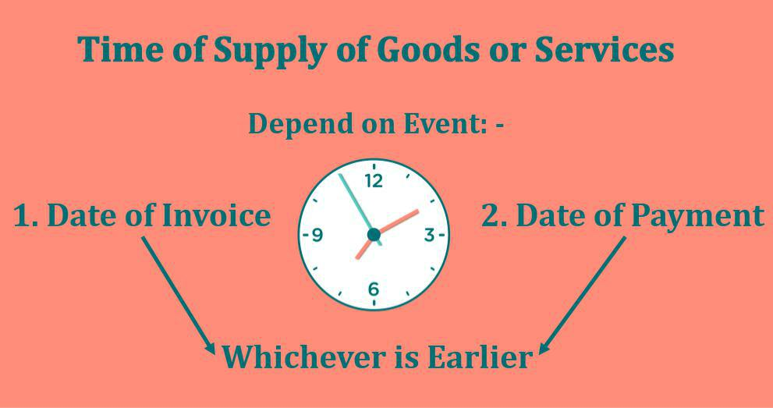

30

www.tutorstips.com/category/tax-laws/goods-and-services-tax

GST E-Book

Earliest of the following: -

- Date of issue of an invoice by the supplier. (If the invoice is not issued, then the last date on which the supplier is legally bound to issue the invoice with respect to the supply).
OR

- Date on which the supplier receives the payment: -

  - The date of the supplier records the payment in his books

OR

  - The date on which the payment credited to his bank account.

Example:-

- Date of issue of invoice is 21/02/2018

- Date of receipt of payment in bank account 15/01/2018

- Date of records the payment in the books of supplier 16/01/2018

Time of Supply will be whichever earliest 15/01/2018

2. How to determine the Time of supply of Services.

Earliest of the following dates:

The Date of issue of an invoice by the supplier (If the invoice is issued within the legally prescribed period under section 31(2) of the CGST Act) or the date of receipt of payment, whichever is earlier?

OR

The Date of the provision of service (If the invoice is not issued within the legally prescribed period under section 31(2) of the CGST Act) or the date of receipt of payment, whichever is earlier?

OR

Date on which the recipient shows the receipt of service in his books of account, in case the aforesaid two provisions do not apply

3. If the payment made in excess of invoice value?

If payment made against invoice is excess from invoice value up to Rs. 1,000/- than supplier can pay tax on excess payment when next invoice will be generated for the same party.

31

www.tutorstips.com/category/tax-laws/goods-and-services-tax

GST E-Book

For example: -

If Firm “AB Co.” make payment of Rs. 5,000/- on 09/01/2018 to the firm “BC Co.” and “BC Co” supply goods on 21/01/2018 to “AB Co.” and generate an invoice for Rs. 4,400/-. Then the Time of supply of goods is 09/01/2018. The date of invoice of next supply to “AB Co.” is 12/02/2018, then supplier has the option to treat the time of supply of balance amount either 09/01/18 or 12/02/2018

- How to determine the time of supply of goods when the tax is to be paid on reverse charge basis?

Whichever is the earliest form following: - 1. The date of receipt of goods.

OR

- The date on which recipient recorded the payment in his books.
OR

The date on which the payment debited from his bank account
OR
- The date immediately following 30 days from the date of issue of invoice or any other legal document in lieu of invoice by the supplier

If we cannot determine the time of supply in an aforesaid manner, then the time of supply will be the date of record of the transaction in the books of accounts of the recipient.

- How to determine the time of supply of services when the tax is to be paid on reverse charge basis?

Whichever is the earliest form following: -

1. The date on which recipient recorded the payment in his books.
OR
The date on which the payment debited from his bank account

OR

- The date immediately following 60 days from the date of issue of invoice or any other legal document in lieu of invoice by the supplier

If we cannot determine the time of supply in an aforesaid manner, then the time of supply will be the date of record of the transaction in the books of accounts of the recipient.

32

www.tutorstips.com/category/tax-laws/goods-and-services-tax

GST E-Book

- Time of supply of goods or services related to an addition to the value of supply by way of interest, late fees or penalty.

Time of supply of goods or services related to an addition to the value of supply by way of interest, late fees or penalty will be the date on which supplier receives that additional amount.

33

www.tutorstips.com/category/tax-laws/goods-and-services-tax

GST E-Book

11. Place of Supply of Goods
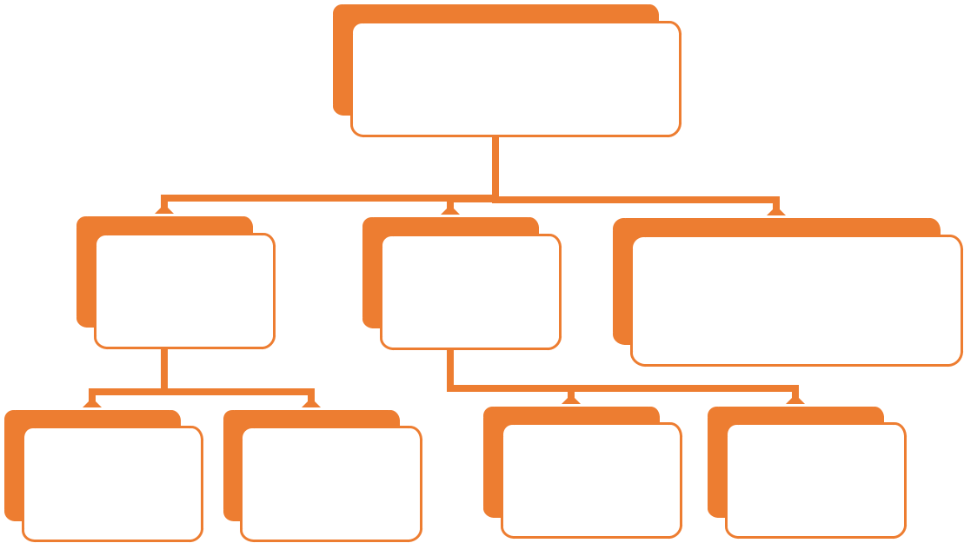

Place of Supply

1. Place of |  | 2. Place of | 3. Special Provision for
Supply of |  | Supply of | supply of online
Goods |  | Services | informations or
 |  |  | database.
Supply | Supply | Supply | Supply
within | outside | within | outside
India | India | India | India

Place of Supply under GST Act is very crucial concept because the GST is charged on basis of Place of Supply of goods or Services. Under GST law Tax is payable where goods or services are consumed.

For Example: - if the place of supply of goods or service is located in same State/UT then SGST/UTGST and CGST will be charged.

if the place of supply of goods or services is located in another State/UT then only IGST will be charged.

So, Place of supply is the base which determines the type of GST will be levied (CGST, SGST/UTGST or IGST). GST is Destination base tax. So, in order to determine the destination of consumption of goods & services, Place of supply has to determine.

In this chapter we will cover following topics: -

- Place of Supply of Goods
  - Supply within India

      - Place of Supply in cases where goods are moved?
      - Where are goods not moved?
      - Supply of Goods on Conveyance?
      - Supply other than above?

    - Supply Outside India
- Place of Supply of Services
- Special Provision for supply of online information or database.

34

www.tutorstips.com/category/tax-laws/goods-and-services-tax

GST E-Book

1.Place of Supply of Goods

1. Supply within India
1. Place of Supply in cases where goods are moved?
Place of supply shall be the place where movement of goods terminates, it means the last destination of goods where actually goods will have consumed.

We will further explain with following illustrations: -

Illustrations 1.
Mrs Radhika for Hoshiarpur, Punjab sell 10 Pcs of dresses to Mr Rahul from Jalandhar, Punjab

In that case, Place of supply is Jalandhar, Punjab. It is within the same state (Punjab) so, CGST & SGST will be charged.

As we explained earlier this is Intra-state supply.

Illustrations 2.

If Mrs Radhika for Hoshiarpur, Punjab sell 10 Pcs of dresses to Mr Joy from Patna, Bihar.

In that case, Place of supply is Patna, Bihar. It is outside state (Punjab) so, IGST will be charged.

As we explained earlier this is Inter-state supply.

Illustrations 3.

Mrs Aman for Hoshiarpur, Punjab sell 10 Pcs of handmade antiques to Mr Sahib from Noida, Haryana and Mr Sahib request to Mrs Aman that to send goods to Mr Pawan form Jalandhar, Punjab

In that case, it will be assumed that the buyer from Noida has received the goods and So, Place of supply is Noida, Haryana. It is outside state (Punjab) so, IGST will be charged.

This case is similar to E-commerce sale i.e. gifting to someone from an online shop like Amazon, PayTM and Flipkart etc.

Illustrations 4.

Mr Sarb for Hoshiarpur, Punjab sell 10 Pcs of handmade antiques to Mr Abhi from Faridabad, Haryana and Mr Abhi request to Supplier that

35

www.tutorstips.com/category/tax-laws/goods-and-services-tax

GST E-Book

he will arrange his own transportation and takes goods from Ex-factory.

In that case, it Supplier will deliver goods to the buyer at their Place Hoshiarpur, Punjab So, Place of supply is Hoshiarpur, Punjab. It is within the state (Punjab) so, CGST & SGST will be charged.

2. Where are goods not moved?
The goods which are not moved from one place to another like sell Studio setup installed in building the building.

Illustrations 1.

M/s Happy Movement Studio from Hoshiarpur, Punjab want to open their branch at Gagret, Himachal and they purchased old studio with the whole setup.

In that case, there is no movement of goods so, Place of supply is a place of goods at the time of delivery. Place of supply is Gagret, Himachal. It is within the state (Punjab) so, CGST & SGST will be charged.

Illustrations 2.

M/s Happy Movement Studio from Hoshiarpur, Punjab want to open their branch at Parwanoo, Himachal and they ask M/s Studio Maker Ltd. From Kalka, Haryana

In that case, there is no movement of goods Because of M/s Studio Maker Ltd. From Kalka, Haryana will build a studio site, Place of supply is a place of the site where they did work. So, Place of supply is Parwanoo, Himachal. It is within the state (Punjab) so, CGST & SGST will be charged.

Note: -

M/s Studio Maker Ltd. has to get GSTIN from Parwanoo, Himachal. They can opt register as a casual taxable person.

3. Supply of Goods on Conveyance?
In case of travelling by plane or train the place of supply is the place from where food loaded in the plane or train.

Illustrations 1.

Mr Arun travels from Chandigarh to Delhi by plane and he purchases a cold drink while on the plane.

36

www.tutorstips.com/category/tax-laws/goods-and-services-tax

GST E-Book

Because plane takes off from Chandigarh So, it was loaded from Chandigarh so Place of supply is Chandigarh. Airline will charge UTGST and CGST on it because in most of the cases all airlines have a pan-India presence and will be registered in all states

4. Supply other than above
If the Place of supply cannot be determined by above- prescribed manner then it shall be determined in the manner prescribed by Central Government on the recommendation of GST Council.

2. Supply Outside India
In the case of Import into India, the place of supply is the location of importer where goods are received.

On Import into India IGST will be charged under GST Law

In the case of Export from India, the place of supply is a location outside India.

Export from India is fully exempted under GST Law

37

www.tutorstips.com/category/tax-laws/goods-and-services-tax

GST E-Book

12. Place of Supply of Services

As continuity of Place of supply of Goods now we will discuss Place of Supply of Services because GST is destination-base Tax system it means GST is to be collected by the state where actual services are consumed.

In this chapter we will cover following topics: -

- Place of Supply of Goods
  - Supply within India

      - Place of Supply in cases where goods are moved?
      - Where are goods not moved?
      - Supply of Goods on Conveyance?
      - Supply other than above?

    - Supply Outside India
- Place of Supply of Services
  - Supply within India

      - Supply to Registered Person

      - Supply to Un-Registered Person
c)

2. Supply Outside India

    - Special Provision for supply of online information or database.

- Supply within India

  - Supply to Registered Person: -

IGST Act provides the provision under section 12(2)(a) that the place of supply of services made to the registered person then of the place of supply of services shall be the place of such person. But place of supply for some services are determined by IGST Law which are mention in section 12(3) to 12(14) of IGST Act. Details of these sub section are in Table below: -

b) Supply to Un-Registered Person: -

If the supply of services made to un-registered person, then the Place of supply is the address of recipient which was recorded in the record of the supplier of services. In all other cases, It will be the Place of supplier of services.

38

www.tutorstips.com/category/tax-laws/goods-and-services-tax

GST E-Book

Section/
Sub |  | Services |  |  |  | Place of Supply of Services
Section
12(1) | All services which are not cover in |  |  |  |  | As explain above in two points
& | Sub section 3 to 12
12 (2)
12 (3) | Directly in relation to immovable |  |  |  |  | The location of such immovable
 | properly | like |  | architecture, |  | property
 | construction, accommodation, event
 | etc.
12 (4) | Restaurants, |  | catering, |  | grooming | Place where such services are actually
 | health services including |  |  |  | cosmetic | performed
 | and plastic surgery
12 (5) | Training and performance appraisals |  |  |  |  | Registered recipient - Place of the
 |  |  |  |  |  | recipient.
 |  |  |  |  |  | Unregistered Recipient – where the
 |  |  |  |  |  | Services are actually performed
12 (6) | Admission to cultural, artistic event, |  |  |  |  | Place where such event is held or
 | amusement park etc. |  |  |  |  | where such park id located
12 (7) | Organizing |  |  | of | cultural, | B2B - Place of Recipient
 | entertainment, |  | conferences, Trade |  |  | B2C – where event actually held
 | fairs etc.
12 (8) | Transportation |  | of | Goods | including | B2B - Place of Recipient
 | mail or courier |  |  |  |  | B2C – Place where goods are handed
 |  |  |  |  |  | over to Transporter
12 (9) | Transportation of Passengers |  |  |  |  | B2B - Place of Recipient
 |  |  |  |  |  | B2C – Place where Passenger embarks
 |  |  |  |  |  | on the conveyance for continuous
 |  |  |  |  |  | journey.
 |  |  |  |  |  | But Return journey shall be treated as
 |  |  |  |  |  | separate journey even if the passenger
 |  |  |  |  |  | for onward.
12 (10) | Services on board a conveyance |  |  |  |  | Frist Scheduled point of departure of
 |  |  |  |  |  | that conveyance
 |  |  |  |  |  | For Example: -
 |  |  |  |  |  | M/s Kingfisher airline hires a doctor
 |  |  |  |  |  | for the passengers travelling from
 |  |  |  |  |  | Delhi to Mumbai. In such a case
 |  |  |  |  |  | although the services by doctor have
 |  |  |  |  |  | been provided on board but the place
 |  |  |  |  |  | of supply shall be Delhi
12 (11) | Telecommunication Services
 | • Fixed telecommunication lines |  |  |  |  | • Location of telecommunication
 |  |  |  |  |  | line
 | • Mobile connection for |  |  |  |  | • Location of billing address of
 | telecommunication |  |  |  |  | the recipient
 | • Mobile connection for |  |  |  |  | • Address of the selling agent else
 | telecommunication, internet, |  |  |  |  | location of where pre-Payment
 | DTH T.V. on prepayment basis |  |  |  |  | is received

39

www.tutorstips.com/category/tax-laws/goods-and-services-tax

GST E-Book

 | • Other Cases |  |  | • Address of the recipient as per
 |  |  |  | records
12 (12) | Banking and | Financial Services |  | Location of the recipient of the
 | (Including stock Broking) |  |  | services else location of supplier.
12 (13) | Insurance Services |  |  | B2B – Place of Recipient
 |  |  |  | B2C – Location of recipient on records
 |  |  |  | of the supplier
12 (14) | Advertisement | services | to | Location of the state of advertisement
 | Government

  - B2B – Business to Business

  - B2C – Business to Customer

- Supply Outside India: -

Place of supply of services is the location of the recipient of the services if the place of the recipient is not available than the place of the supplier will be the place of the Supply of Services.

3. Special Provision for supply of online information or database.

As per Section 2(17) of the IGST ACT, “Online information and database access or retrieval services means services whose delivery is mediated by information technology over the internet or an electronic network and the nature of which renders their supply essentially automated and involving minimal human intervention and impossible to ensure in the absence of information technology”.

40

www.tutorstips.com/category/tax-laws/goods-and-services-tax

